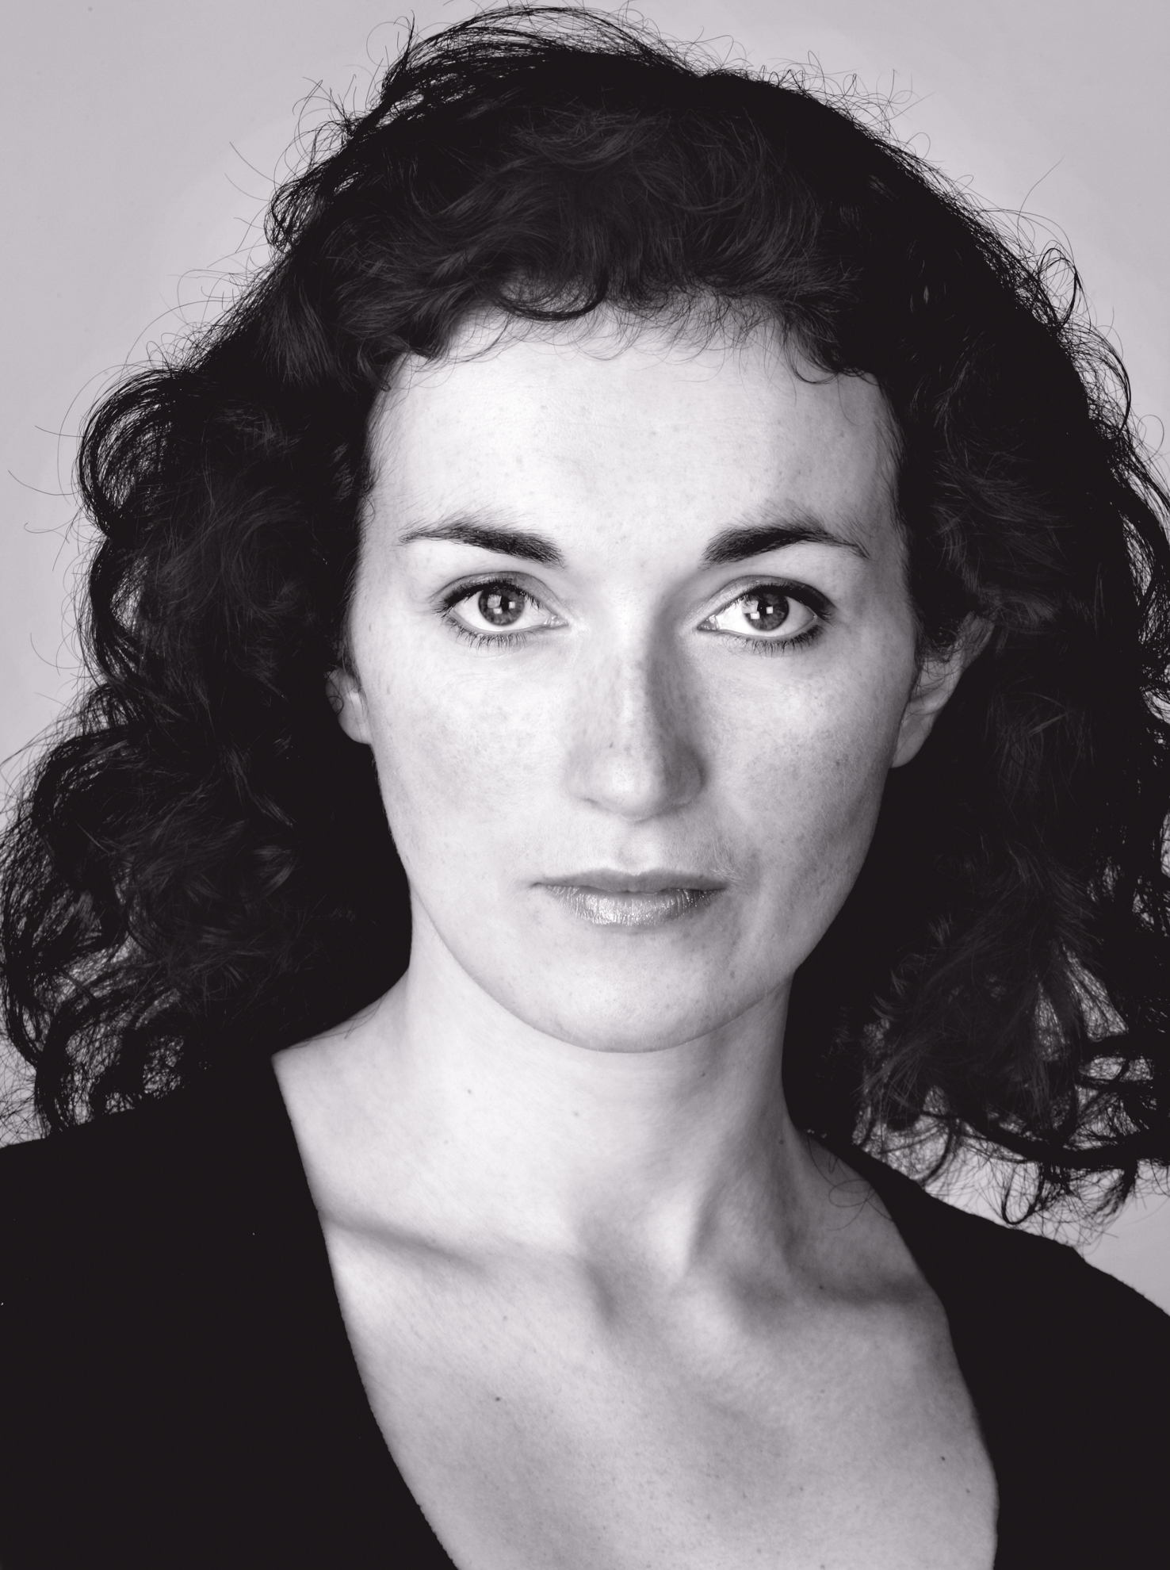
087 9320885
Tazpoppy@hotmail.com
Height: 5’7” Weight: 9st
Eyes: Blue /Green Hair: Black
Agent: The Ann Curtis Agency 01 8327708
Equity Member

Training

TARA BREATHNACH
The Royal Welsh College of Music of Drama: Graduate Diploma Acting
Gaiety School of Acting, Artstrain, (National Association of Youth Drama), Galway Youth Theatre, Dublin Youth Theatre. Workshops with Chrissie Poulter, Annie Ryan, Mikel Murfi, Max Hafler, Macnas, Emilyn Williams, Corn Exchange, Branar
Loose Canon Theatre Company. Classic Stage Ireland: foundation course classical acting.
Second Age Theatre company: Shakespeare .Television Presenting, Skillsnet and TG4
Theatre Role Director Venue /Company

Yummy Mummy Hatchetsoup Eamonn Dreaper Taibhdhearc
The Donahue Sisters Dunya Cathal Cleary Zeilig Theatre Co
Deirdre Deirdre Kelly Mac Mahon Lyric Theatre
Jackie’s Day Storyteller Emelie Fitzgibbon Graffiti Theatre Company
Jude Gráinne Sean Ó Tarpaigh Taibhdhearc
Mamó Gé Strainc Diarmuid De Faoite Taibhdhearc
Metamorphosis Mrs Samsa Lisa May Bruiser Theatre Company
Master Shuttlefate Mama /Detainee Acushla Bastible Angel Exit
Tine Chnámh Virgie Darach Mac Con Iomaire Taibhdhearc
Osmosis Tv Ensemble Lindsey Jackson Red Umbrella
Incubus Roisin Thomas Seoige An Taibhbearc
The Goat or Who is Slyvia Stevie Lily Hill Town Hall Theatre
The Well of The Saints Chorus Garry Hynes Druid Theatre Company
Dracula Florrie /Vampire Martin Houghton Welsh College of Drama
Dolly West’s Kitchen Dolly West Tim Baker RWCMD
Lady from the Sea Elida Martin Houghton RWCMD
Bards In the Yard Jester Rebecca Bartlett NAYD
A Dublin Bloom Molly Bloom Antoinette Duffy Gaiety School of Acting
Gráinne Mhaol Clan Member Kathi Leahy Macnas /Belgrade Theatre
The Crucible Mercy Lewis Niamh Dillon Galway Youth Theatre
Television /Film Role Director Venue /Company

Na Cloigne Banaltra nic Lochlainn Robert Quin Rosg
Ros na Rún Tina O’Dowd Deirdre Friel TG4 /Tyrone Productions
Aifric Imelda Uí Liodán Paul Mercier Telegael
Perspective Woman Eoin Rogers Canon Productions
Paddywhackery Shop Assistant Daniel O’ Hara TG4
Rough Diamond Mary Lou Dermot Boyd BBC
Story Lane Curious Kate Claire O’ Loughlin RTE
Fallout Janine David Caffrey Frontier Films
Manhunt /Ar an Seachaint Agnes Mc Donnell Paddy Hayes Flutterby Films
Tracy Beaker 4 ep. 13 Nurse Nadia Jill Robertson BBC
Tristan and Isolde Bridesmaiden Kevin Reynolds Octagon Films
Skills

Accents: Galway (native), Dublin, Northern Irish, R.P., Northern England, Standard Scottish, Standard
Languages: Irish (fluent), German
Combat: Silver Award: BADC Basic
Dance /Movement: General Movement Training, Modern, Period Dance, Yoga, Swing Dance, Lindy Hop, Charleston, Six Beat, Jazz,.
Others: Horse Riding, Stilt Walking, Youth Drama Facilitation, Street Theatre, Macnas
Parade, Macteo Corporate Events and Performances, BA Art History and Textile Design
Commercials for An Post, Dairygold. Voiceover, An Post, Abú Media cartoons.

