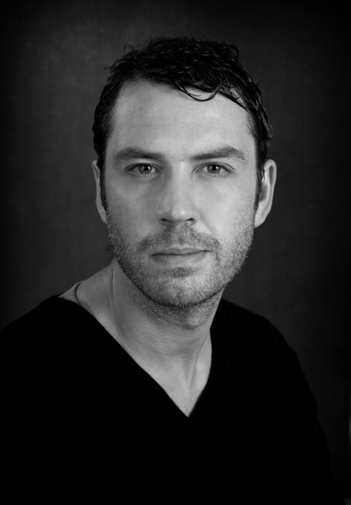
Robert O'Connor
Height: 6’1
Weight: 12.5st
Hair Color: Brown
Eye Color: Green
Playing Range: 27-37

Contact Number: 086 034 2392 – Email Address: robert.oconnor2@gmail.com

Theatre Credits:

- Wedding Guest/Woodcutter, Blood Wedding, Ronnie McCann, The Project Arts Center
- Ballie, No Worst There Is None, Dylan Tighe, Ulster Bank Theatre Festival
- Paul, Down the Flats, Michael Roddy, Liberty Hall
- Hairoil, Hatchet, Frank Allen, Liberty Hall
- Jeremy, Give us a Break, Mary Murray, Crypt Theatre
- Paul, Kevin’s Bed, Bernard Farrell, Andrew’s Lane
- Fed-Ex Man, Fed-Ex Man, Shay Lenihan, Bewlely’s Theatre

Film & Television:

- Card Player, Dark by Noon, Alan Leonard, Vico Films
- Michael, (Lead) The Nixer, Fiona Graham, Guerrilla 12 Productions
- Down & Out, No Party for Billy Burns, Padraig Conaty, Whinbush Productions
- Protester, A Portrait of a Zombie, Bing Bailey, Organ Hill Productions
- Nightclub Manager, Mr. Donkey, Christian Koety, Rising Film Productions
- Theo Van Gogh, The Method, John Karabestos, Cuchulainn Films
- Captain Stanley, The Daughters of James Connolly, Frank Allen, Rascals Films
- Fergal, The Methadone Actors, Frank Allen, Rascal’s Films
- Peter, Rural Heat, David Brown, Dun Laoighaire Film School
- Lead Role, Vespa TV3 Commercial, Damien O’Donnell, Ardmore Studios

Training:
The Gaiety School of Acting
1999-2000
The Betty Ann Norton, School of Drama
2007-2008

Accents & Dialect’s:
American, English, Irish (good ear for all accents)

Skills & Sports:
Rock Climbing, Parachute Jumping, Bungee Jumping, Swimming, Horse Riding, Fire Arm Training, Martial Arts Training

Industry Membership:
Full Member of the Irish Film & Television Academy (IFTA) Membership Number 1545

