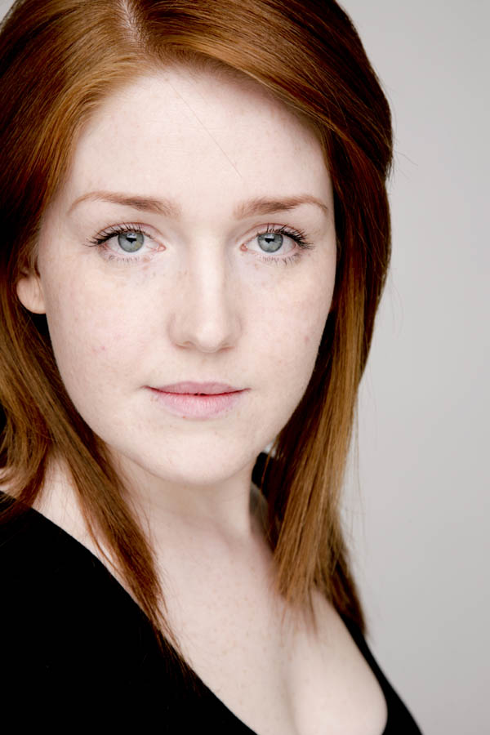
40 Old Colin Road
Dunmurry, Belfast
BT17 ONS
MOB N.I: 07578714705
HOME: 02890 622292

Eye Color: Blue/Green
Hair Color: Red
Build: Slim
Height: 5ft
Playing Age: 17-25

I am a very passionate actress and love every aspect of the performance art scene, however my heart lies with film and theatre as I believe this truly is where all the blood sweat and tears go but where the magic happens.

I have had the privilege to study most recently in the Stella Adler Acting Studios which was an amazing experience to say the least. I am a proud and current member of the Belfast Actors Studio and have been a member of Living Tours Belfast which uses Street theatre. I have recently finished and held two lead roles in FEA’s film production of Cold Blood and Pink Naked. I also held lead role in Accidental Theatre’s comedy production of ‘Job Interview’ a two woman show for entertainment at the highly claimed Black Box. I have in recent times been in Michael Poynor’s ‘Romeo and Juliet’ and Stephen Begg’s ‘Mechanicals’ I have taken part in a variety of workshops of the over the years most notably being the Hubbard’s and have also completed a film acting course in Galway, which opened my eyes to the world of film. I have been casted as Aine in Grainne Curistan’s film ‘Aine.

I have a great love for horses and have competed nationally at show jumping and eventing at a highly skilled level. I also have a degree in social policy. I like to observe and analyze people and learn what makes them tick.

My character is split between my fun loving side and my serious side. I am not afraid to act the fool, I like to make people laugh and can see the funny side in even the worst situations but I am very serious about my work and I am a very committed and loyal person, I want to further my career in the film world as this is where my heart lies.

FILM EXPERIENCE

FILM | ROLE | THEATRE/DIRECTOR
The Making of Cold Blood  Cold Blood  Pink Naked  Aine  THEATRE  Aftermath  A Friend In Need  Living Tours  Belfast  Living Tours Belfast  Living Tours Belfast  Romeo and Juliet  Mechanicals  Job Interview  The plan | Naseen*(Mocumentary about the chilling making of Cold Blood)  Teach*( A young intelligent vampire, the teacher of the chlann)  Nas* (A woman scorned and wanting revenge)  Aine*(A highly disturbed young women)  Kathleen Doherty*( true story of a girl who’s brother has been killed)  Susan*( A quiet well,mannered girl who may have a chilling other side)  *Kathleen* (A Cheeky Intelligent Linen Mill Girl)  *Martha (A strong personality but light hearted Prostitute)  *Sandra (A highly strung reporter)  Juliet and Cobalt Capulet  *Tom Snout ( The very excited little wall)  Danielle* (A confident, funny, quirky female job seeker who wants to be the next Prime Minister)*  Kimberly* (cheeky but loveable teenager)(Northern Irish accent) | FEA Management (2011)  FEA Management (2010)  FEA Management (2010)  Grainne Curistan (2010)  Brenda Murphy/Pam Brighton(2011)  Gary Wilson (2011)  Janice Kernoghan(The Clinic Theatre)(2010)  Janice Kernoghan(The Clinic Theatre)(2010)  Janice Kernoghan(The Clinic Theatre)(2010)  Michael Poynor (Belfast Actors Studio Botanic Gardens)(2010)  Stephen Beggs(Belfast Actors Studio Botanic Gardens)(2010)  Richard Lavery(accidental theatre Company) The Black Box(2010)  Maura O’Reilly(2007  Blackbird Theatre)
Waiting | Carolanne*(A annoyed English business woman) | Maura O’Reilly( 2006Blackbird Theatre)
Storm | Aoife*( A young controlled abused, trafficked prostitute) | Sim Mac Coinnich(2005)
Storm | Cherie*(A funny, quirky, self confessed snob, who loves the riches of life) | Brendan Murray(2005)
Storm | Death(A dark, deep character that represents famine around the globe) | Sim Mac Coinnich(2005)
Storm | Dancer(A young hearted traditional dancer, the spirit of the dance) | Sim Mac Coinnich(2005)
An Dilleachtach  The Party | Jackie and Tara  (READING)American Teenagers(American accent)  Sarah*( A friendly yet vengeful nail technician) | Culturlann(2006)  Diane Maguire(2009)  Crescent Arts Centre

* (indicates lead or central role)

TRAINING

- Stella Adler Studio with Grace Kiley(2011)
- Acting with Belfast Actors Studio
- Screen acting with Ross Hubbard
- Screen acting with Peter Ferris
- Saber stage Combat with Michael Poynor
- Acting workshop with Anna Newel
- Acting workshop with Terrence Zeeman
- Acting with Diane Maguire
- Essential Actors workshop with Seamus Hughes
- On Screen Acting Master class with Joe Dempsie
- Contempory Dance with Bernadette Connolly
- Film Acting Course Dana with Iomairt Cholm Cille- Mfg-Tosg- Trevor O Clochartaigh
- Performance Art with Sim Mac Coinnich
- Improvisation with Sim Mac Coinnich
- Stage Techniques with Brendan Murray
- Blackbird Theatre (Drama Workshops and Training) with Maura O’Reilly

SKILLS
- Languages- I am fluent in Irish and can speak basic French and have an excellent aptitude for accents
- Dialects- Northern and Southern Irish; General American; New York English Old And Modern

ADDITIONAL SKILLS
- Horse-Riding (Eventing and Show jumping- Dressage)
- Novice Tap dancing
- Swimming
- Full Drivers License
- Good Singing Voice
- Novice saber stage combat



