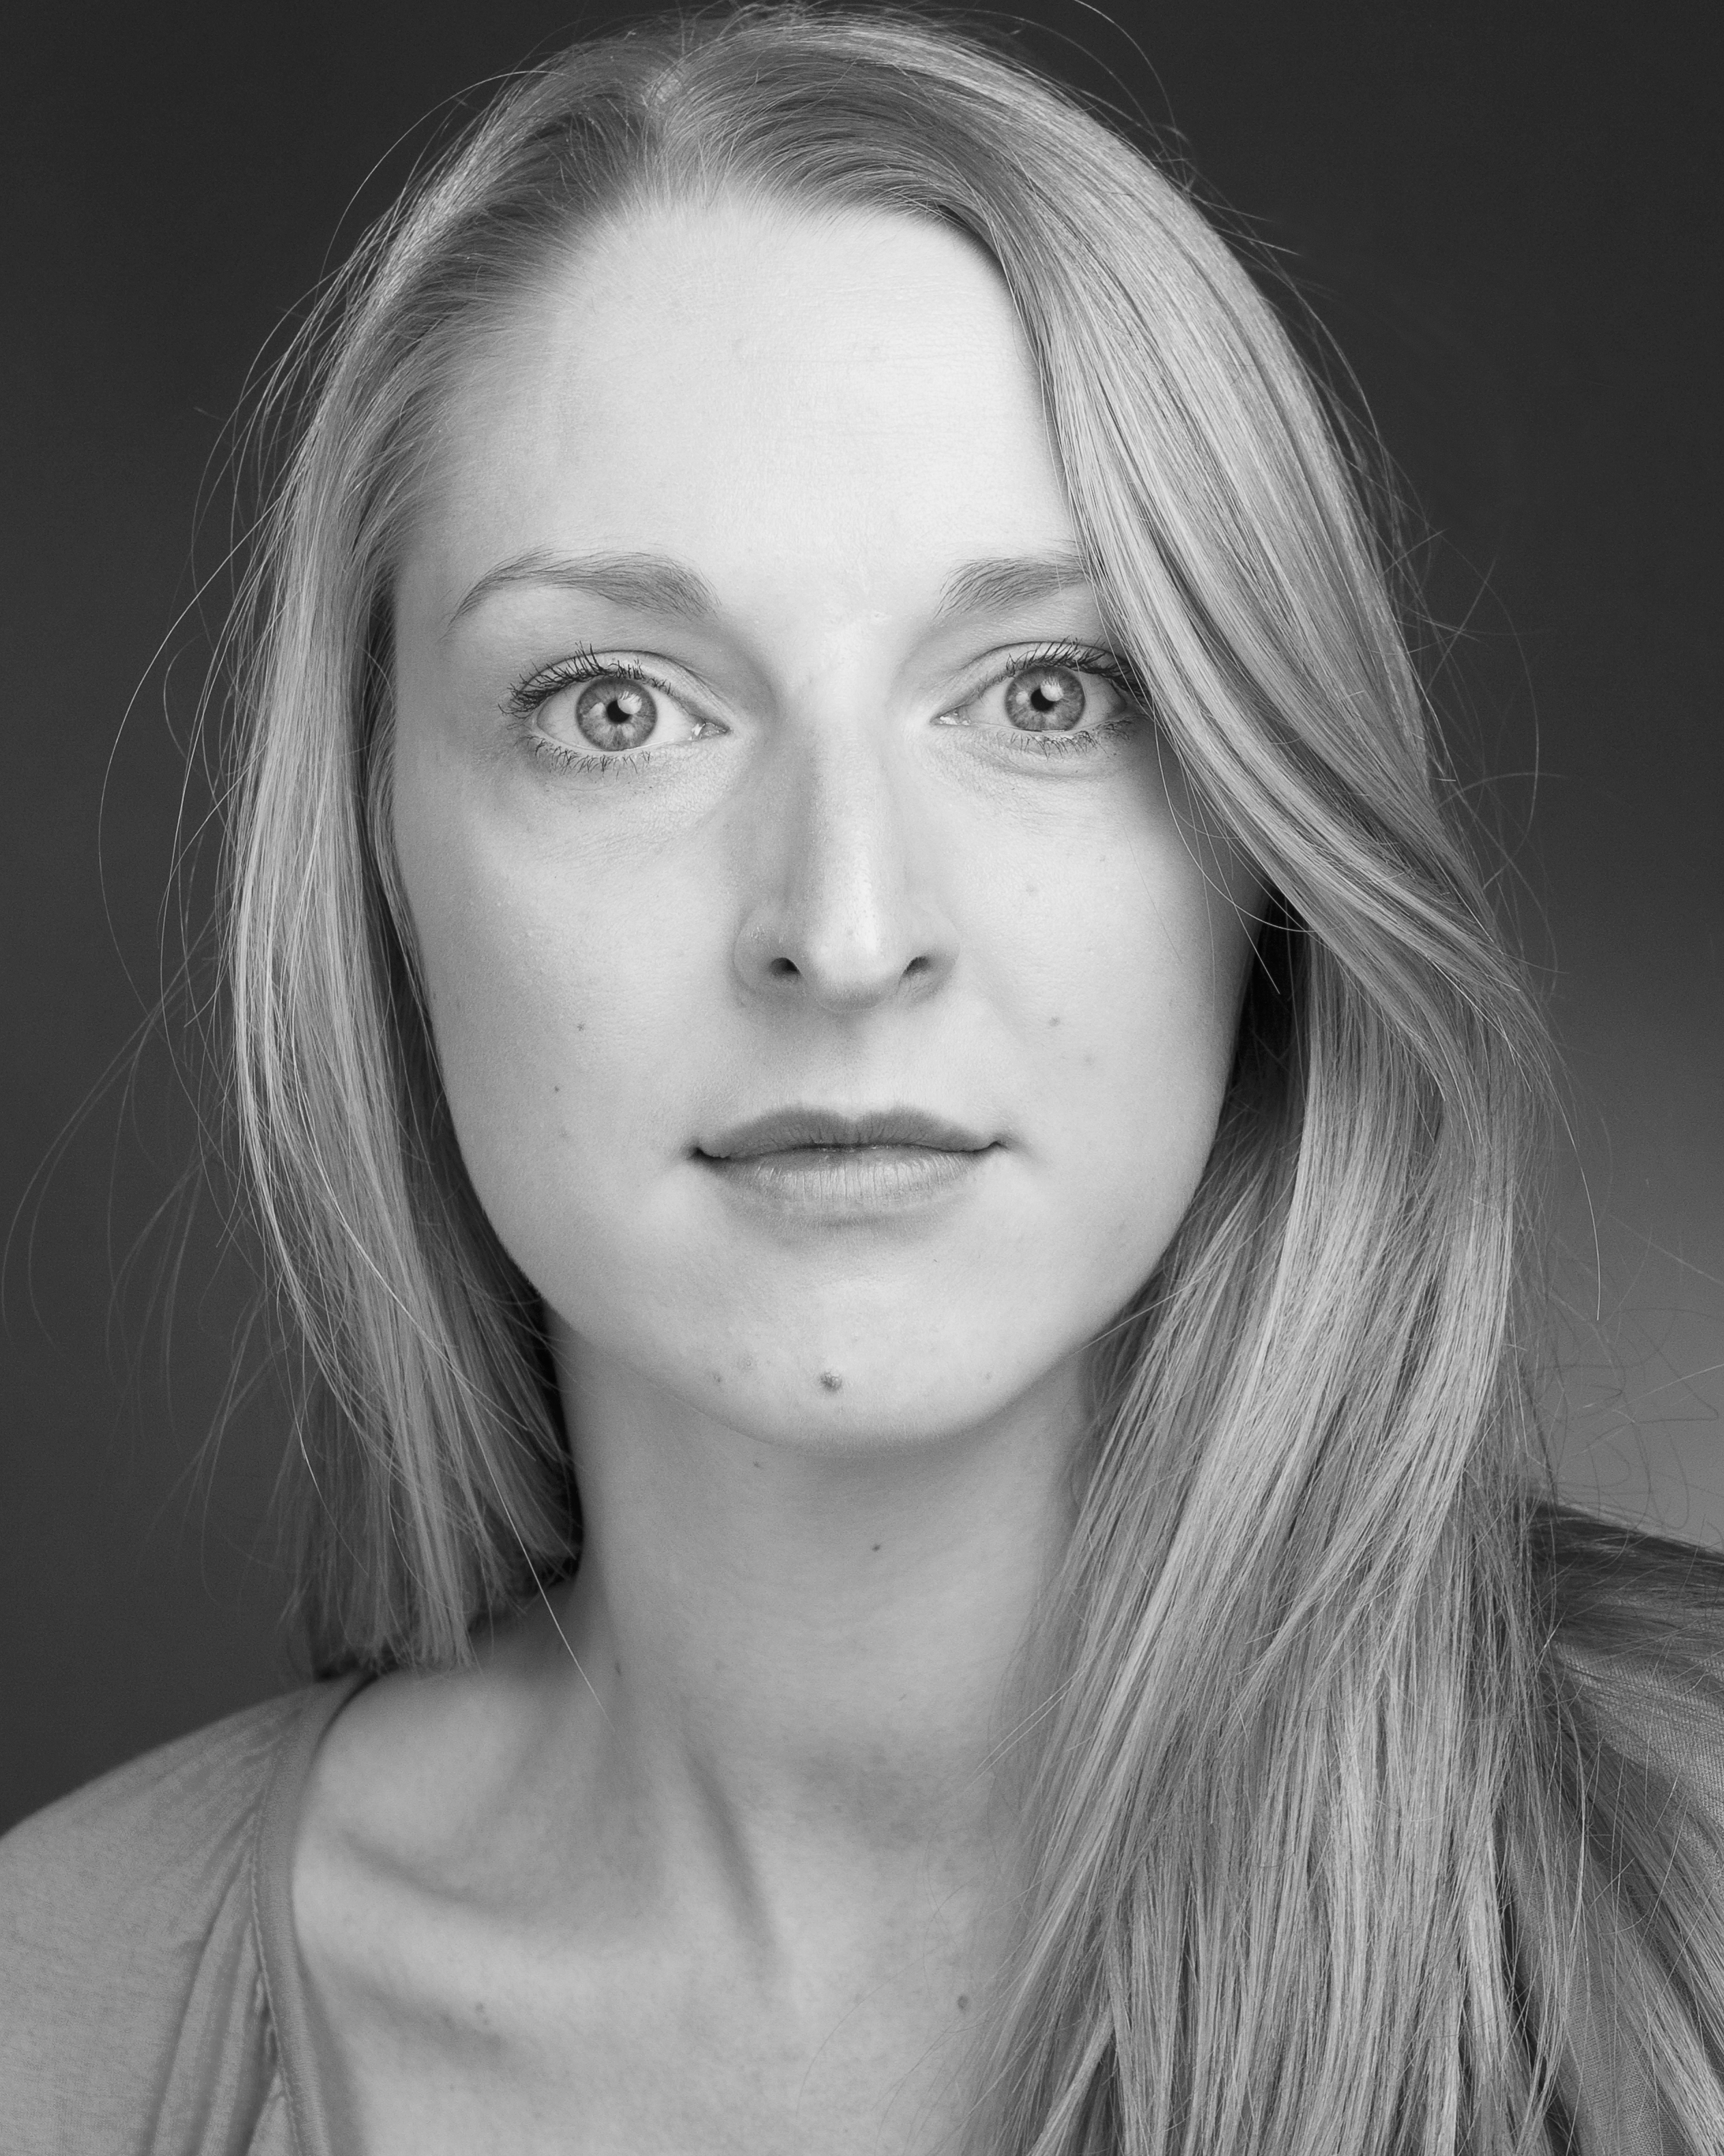
Grace Hendy

E-mail: gracehendy@yahoo.ie
Address: Ballytore, Athy, Co.Kildare.
Phone: +353861940771

Height: 5’7”
Eyes: Blue
Hair: Blonde
Age Range: 16-25

Show Part Director Venue__________
Theatre
Showcase Margarita Miriam O’Meara The New Theatre
The Arabian Nights Azaizah, Kadi Susie Kennedy Project Arts Centre
Attempts on Our lives Grace Peter McDermott DIT Rathmines
The Sun the Moon Woman Alexandra Rosiak Riverbank Arts Centre, And the Apple and Back Loft Theatre
Scenes from Macbeth Duncan Miriam O’Meara DIT Rathmines
The Waiting Room Janet Leish Burke Meeting House,
Ballytore, Kildare Love Lust and the Tess Susie Kennedy DIT Rathmines
Lack of it
Radio
Miss Julie Christine Miriam O’Meara DIT Rathmines
Film
Where did you School Teacher Leish Burke Ballytore, Co.Kildare come from?
See Me Girl Grace Hendy, Kildare
(Music Video) Yvonne Rouse

Training:
BA (honours) Drama Performance DIT Conservatory of Music and Drama, Rathmines.
Film Studies, Radio, Medieval, Shakespeare, Elizabethan, and Restoration Theatre, Contemporary Performance, Stanislavsky and Contemporary Dance, Drama Facilitation, Theatre in Education.

Workshops:
Suzuki Method Master Class (Stephanie Courtney), Screen Acting Master Class (Vinny Murphy), Classical Acting (Royal Shakespeare Company in Stratford Upon-Avon), Le Coque Movement Workshop ( Michael McCabe), Singing (Emmanuel Lawler)

Other Skills:
Good singing voice (soprano), Movement, Stage Combat, Commedia Dell’arte, Belly dancing, Full Driving Licence, Horse Riding, very good swimmer.

Accents:
Phonetically Trained. Good ear for accents. Dublin south and inner city. Regional Irish. Regional English and RP. General American and Regional American.

