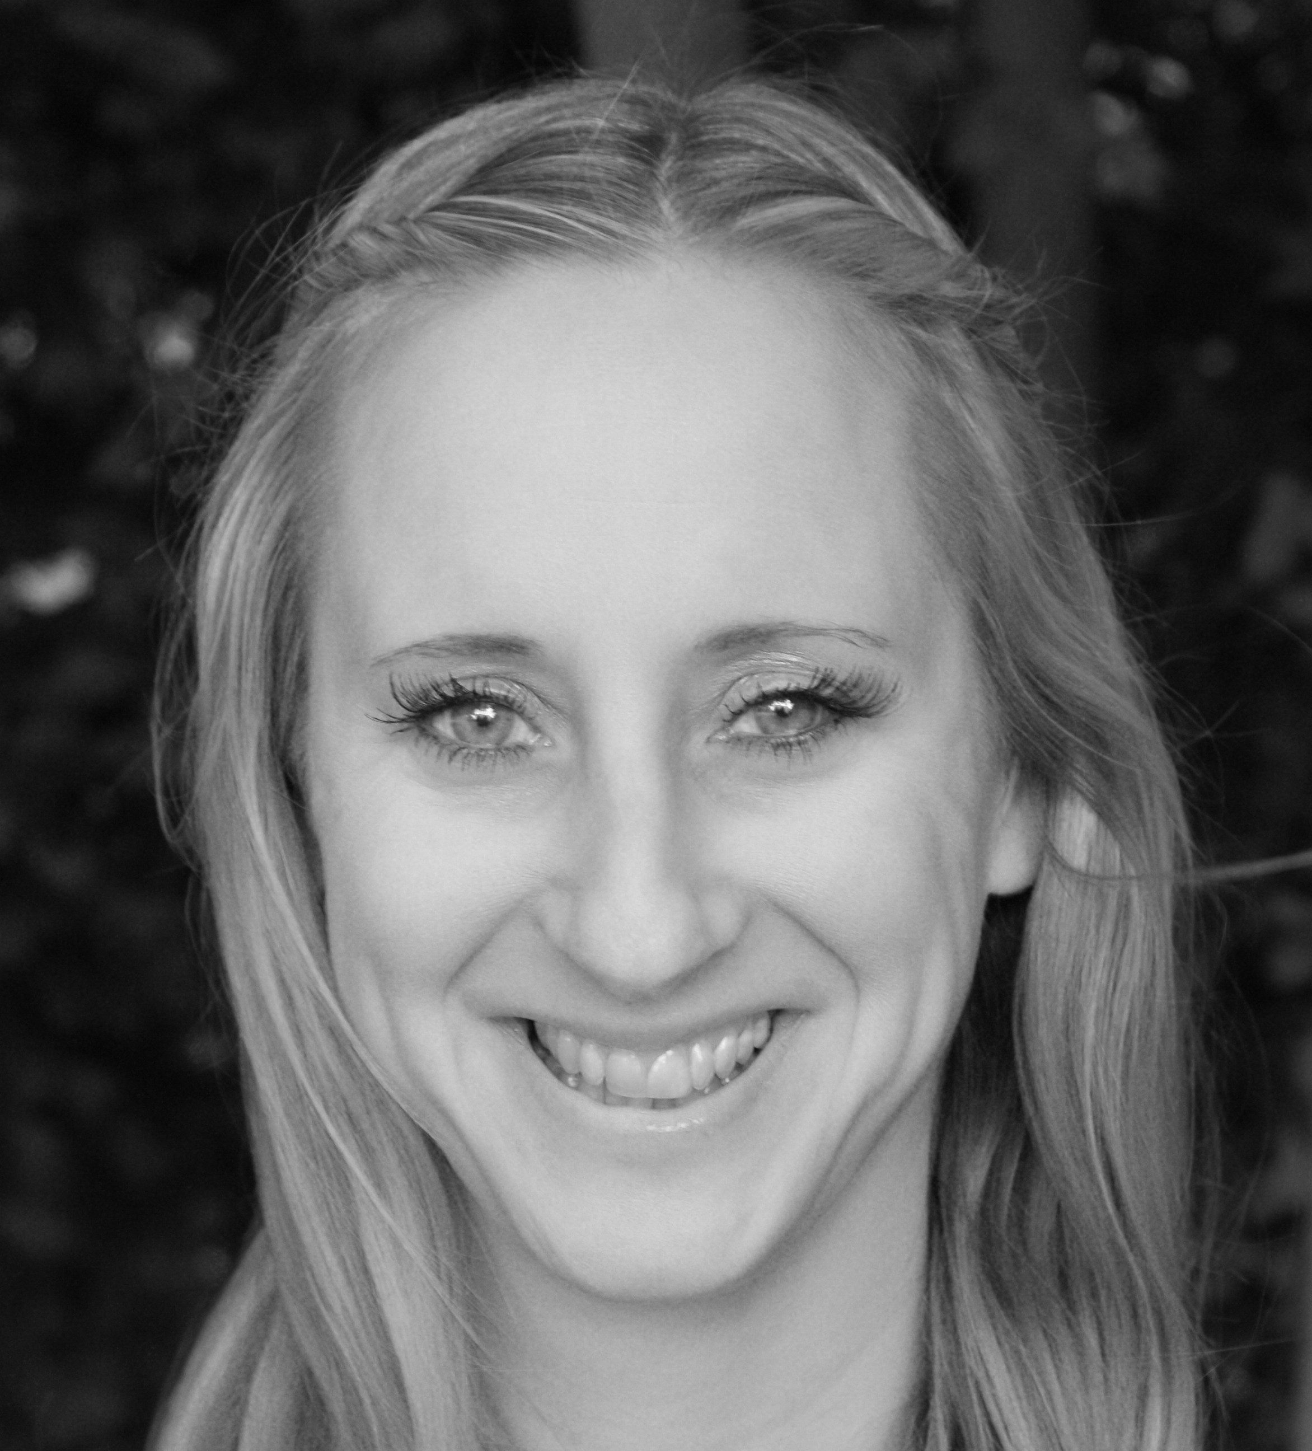
CAROLINE GRACE-CASSIDY
8 Woodstown Lane, Woodstown Village, Dublin 16, Eire.
Tel 00 353 86 3846653
Email carolinegrace@dublin.ie/carolinegracecassidy@gmail.com
REPRESENTED BY:
IRELAND: The Ann Curtis Agency - Office: (00353) 1 8327708 info@anncurtis.ie
UK: Sherina Bartram ONIT Artists - Office: (+44) 0208 834 1266/Mobile: 07547 141 752
Hair: Blonde
Eyes: Green
Height: 5ft 7” (170cm)
Weight: 8st 10 lbs (125lb) (57kg)
Playing range: 27-37
PRODUCTION PART DIRECTOR FILM&TV
Film & Television Work
[‘10] The Guards Emer Whelan Graham Cantwell Legend Pics
[‘09] Your Highness H’aiden David Gordon Green Universal Pictures
[‘09] Fair City Gertie McNamara Paul Cusack RTE
[‘09] Windows Blonde Ken Walshe RTE/IFI CIMEMAS
[‘09] She Owns Everything Sandra Alexandra McGuinness London FS Short
[‘08] MARU Mary Reynolds Lawrence Gough TG4/Stirling TV
[‘08] The House Sheila O’Reilly Declan Cassidy Timesnap
[‘08] How Low Reality Caroline PA Stephen Lonnhoff RTE 2/ Stirling TV
[‘07] Damage Carol Clerk Aisling Walsh RTE 1/Subotica
[‘06] Podge & Rodge Esther Martin Julian Hills RTE 1 & 2/Double Z
[‘06] Fair City Aoife Coleman Stephen Plunkett RTE 1/2
[‘05] Dustins’ Cheers Mother Julian Hills RTE 1 & 2/Double Z
[‘05] Podge & Rodge Lucy Draws Julian Hills RTE 2/Double Z
[‘05] Custers’ Last Stand Up Alison Mull Dearbhla Walsh BBC 1 & RTE

Theatre Work:

PLAY CHARACTER DIRECTOR THEATRE
Poeticus Poet Michael Scott SFX City Theatre
The Agamemnon Persephone Michael Scott SFX City Theatre
A Day in Susan Pat Kinevane City Arts Centre
Hope & Glory Rose Hope Martin Maguire Kilmainham Gaol
Lord Edward Mary-Ann Martin Maguire Guinness Hops

WEBSITE: www.cgcshowreel.wordpress.com
IMDb: www.imdb.com/name/nm3428577
SPOTLIGHT: www.spotlight.com/interactive/cv/8615-4536-8762

SPECIAL SKILLS:
Private RP Classes with voice coach Brendan Gunn (ongoing 2010)
15 years equestrian experience & award winning show jumper; Good singing voice;
Accents & Dialects: Excellent RP; Dublin & Regional Irish; English Standard – all accents; Northern Irish; Eastern European; French; American Standard; Basic Irish; Full Driving Licence and own car.

